**System Design Visual Search System**

Video Link: https://www.youtube.com/watch?v=5mkegPovTI8&list=PL_b_MRp1BnEj4UuHv1jAGeO1a0VTRXsAk&index=5

1. Objective



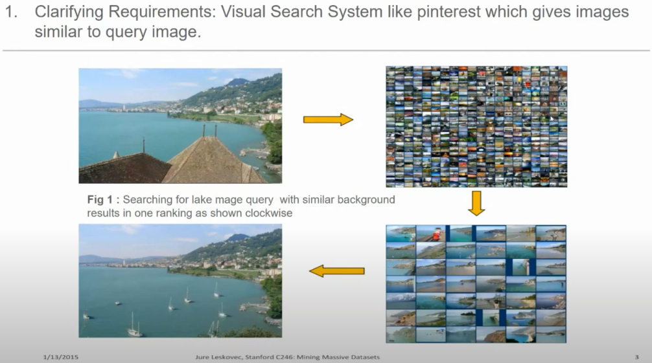

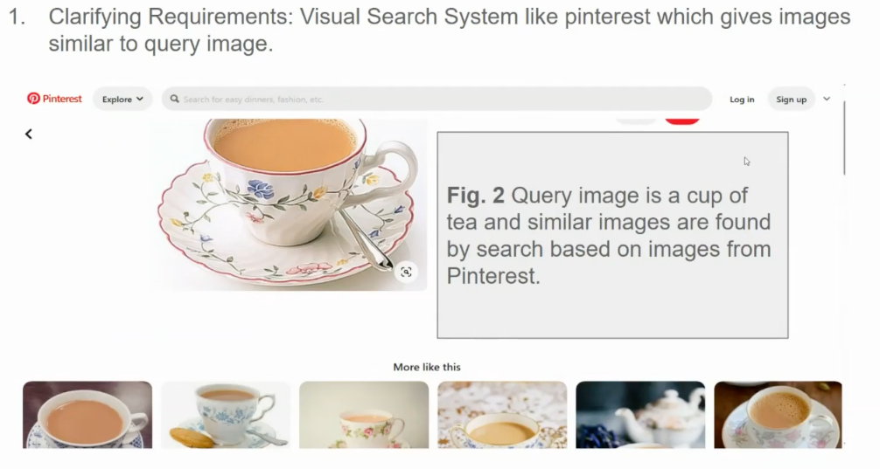

1. Framing problem as an ML task

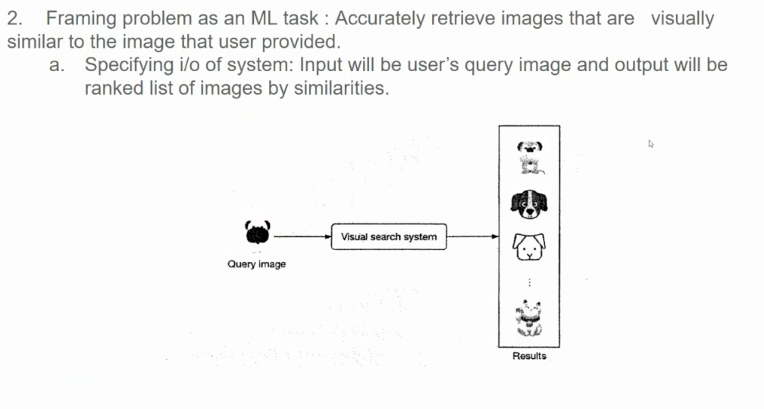

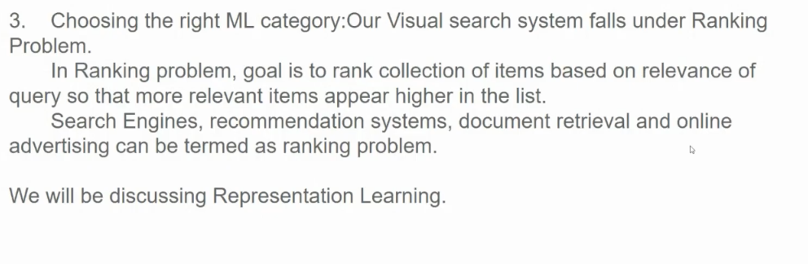

Representation learning is a machine learning approach focused on automatically discovering and organizing features or representations from raw data. Instead of manually designing features, the model learns how to represent data in ways that make it easier for algorithms to perform tasks like classification, clustering, or prediction. Deep learning, such as neural networks, is commonly used for this as it can learn hierarchical and complex features directly from the data. This approach is widely used in image processing, NLP, and recommendation systems.

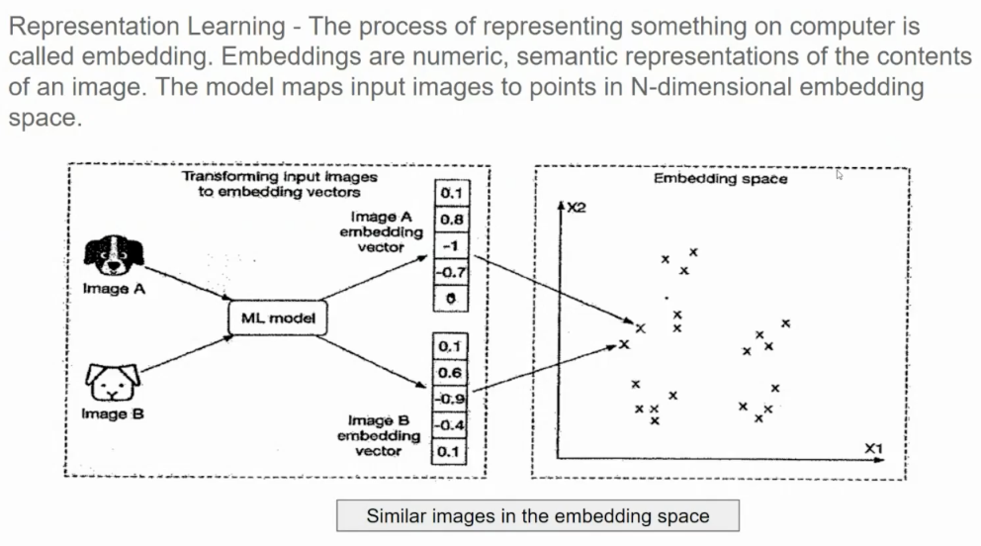

An embedding is a way of converting items (like words, products, or even people) into numbers, making it easier for computers to understand and work with them. It’s like creating a unique "location" for each item in a large "map" of numbers, where similar items are placed closer together. This helps computers recognize relationships, such as how "apple" is similar to "banana" because both are fruits, even though they’re represented by different numbers. Embeddings are essential in tasks like recommendation systems, search engines, and language translation because they help algorithms find and understand patterns.

Embeddings are numerical representations of items like words, images, or products, mapped into a multi-dimensional "embedding space." In this space, each embedding (a vector of numbers) represents an item, and the distance between these embeddings reflects how similar or different the items are.

For example, suppose we have an image embedding model. When we process images of, say, dogs and cats, each image is transformed into an embedding in this space. If two images show similar things—like two different photos of a golden retriever—their embeddings will be close to each other in the space. Images of cats, on the other hand, will form a separate cluster, closer to other cats.

**Finding Similar Images Using Embedding Space**

To find images similar to a given one, we can calculate the "distance" between the embedding of the query image and the embeddings of other images in the dataset. A common way to do this is by measuring cosine similarity or Euclidean distance.

For example:

1. **Query Image**: You input a photo of a golden retriever.
2. **Embedding Search**: The model transforms this image into an embedding vector.
3. **Compare Distances**: The model finds other embeddings in the dataset that are closest to this vector.
4. **Results**: Images of other dogs, especially golden retrievers, appear as the most similar matches.

This method is used in applications like Google Images, where you can search by image, and it finds visually similar images.

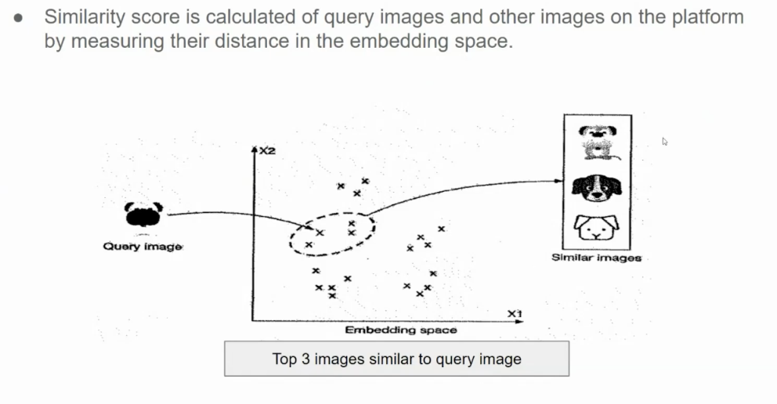

1. Data

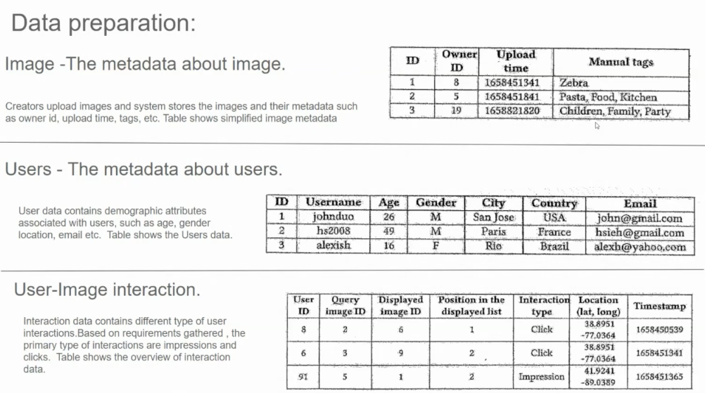

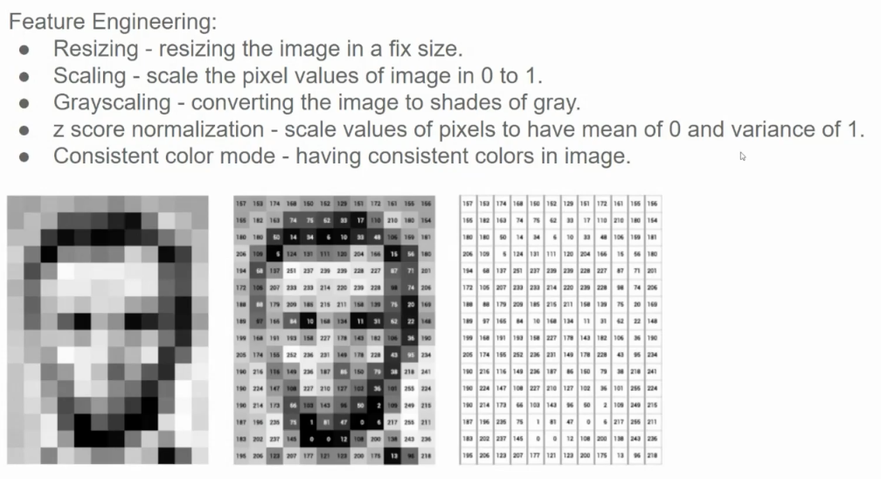

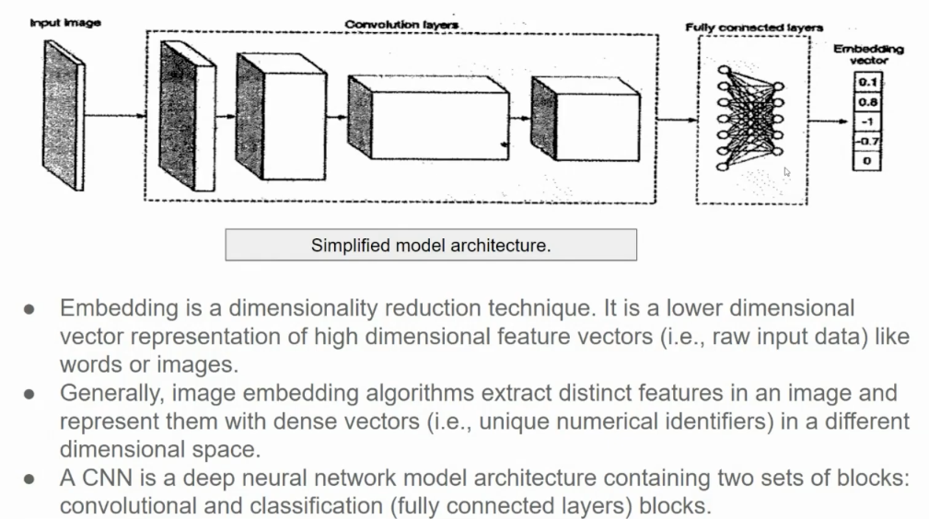

**Diagram Explanation**

1. **Input Image**: The process starts with an input image, which is a high-dimensional array of pixel values.
2. **Convolutional Layers**:
   * The CNN applies multiple convolutional layers to the image. These layers detect various features like edges, textures, shapes, and complex patterns.
   * Convolutional layers progressively transform the raw pixel data into more abstract feature representations. Each layer builds on the features learned by the previous one.
3. **Fully Connected Layers**:
   * After the convolutional layers, the features extracted from the image are flattened and fed into fully connected (dense) layers.
   * These layers further combine and process the features to capture more complex relationships and representations, ultimately reducing the data to a lower-dimensional vector.
4. **Embedding Vector**:
   * The final output from the fully connected layers is an **embedding vector**, a dense, lower-dimensional representation of the original image.
   * This vector is a series of numbers (as shown, e.g., [0.1, 0.8, -1, 0.7, 0]) that uniquely represents the image in a more compact form, which is useful for various downstream tasks like image retrieval or similarity comparison.

**Bullet Point Explanation**

* **Embedding as Dimensionality Reduction**:
  + Embeddings are a **dimensionality reduction technique**. They transform high-dimensional data (such as raw images) into a lower-dimensional vector representation.
  + This is beneficial because it allows for the storage and processing of complex data in a compressed form without losing essential information.
* **Feature Extraction for Dense Vectors**:
  + The process of creating embeddings involves **extracting distinct features** from the input data, whether it's images or text.
  + For images, these features could include patterns, colors, shapes, or textures that uniquely define the content of the image.
  + The extracted features are then represented as a **dense vector** (embedding) in a multi-dimensional space, where similar images (in terms of content or visual features) are closer together.
* **CNN Architecture**:
  + A **CNN (Convolutional Neural Network)** is used here as the model architecture.
  + CNNs typically consist of two main types of layers:
    - **Convolutional layers** for feature extraction (these detect patterns within the data).
    - **Fully connected layers** (classification layers) to interpret and summarize these features into a lower-dimensional output.

**Applications of Embedding Vectors**

* **Similarity Search**: Embedding vectors allow similar images to be easily found. Since images with similar features have embeddings that are close in the embedding space, we can calculate distances (e.g., using cosine similarity) to find images that are visually similar to a query image.
* **Image Classification and Clustering**: The embedding vector can also be used to classify or cluster images. For example, images of cats and dogs will have distinct clusters in the embedding space, making it easy to identify which category a new image belongs to based on its embedding.

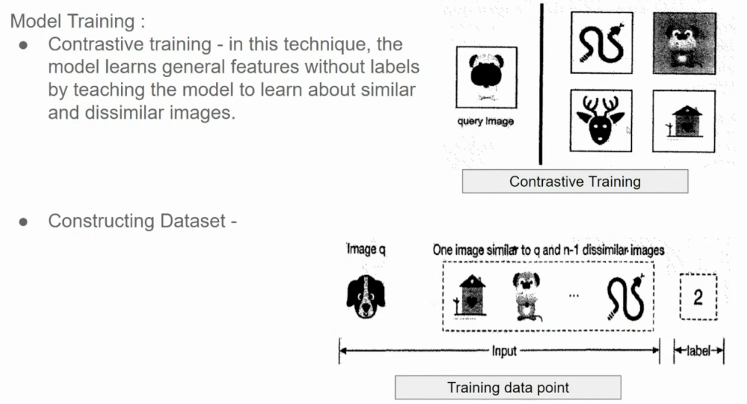

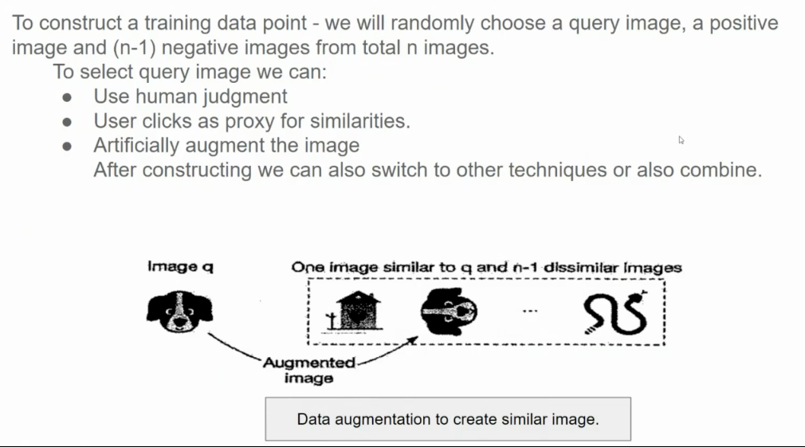

**Contrastive Loss**

**Contrastive loss** is a loss function used in machine learning, particularly in tasks involving similarity learning, such as image and text matching. It aims to minimize the distance between similar pairs while maximizing the distance between dissimilar pairs.

1. **Loss Function**: The contrastive loss for a pair of inputs is defined as:

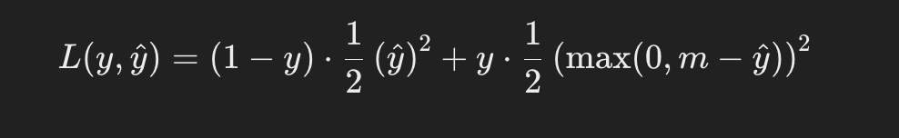

where:

* + y is a binary label (1 for similar pairs, 0 for dissimilar).
  + m is a margin that specifies how far apart dissimilar pairs should be.

1. **Training Data Construction**:
   * **Similar Pairs**: These can be created by augmenting the same data point (e.g., image transformations) or by selecting similar instances (e.g., images of the same class).
   * **Dissimilar Pairs**: These are created by pairing data points from different classes or categories.

**CLIP (Contrastive Language-Image Pre-training)**

**CLIP** is a model developed by OpenAI that learns visual concepts from natural language descriptions. It uses a contrastive learning approach to align images and text.

* **Training**: CLIP is trained on a large dataset of images paired with textual descriptions. During training, it learns to maximize the similarity between the image and its corresponding text while minimizing it for non-corresponding pairs.
* **Architecture**: It typically employs two encoders: one for images and one for text. Both encoders map their inputs into a shared embedding space, where contrastive loss is applied.

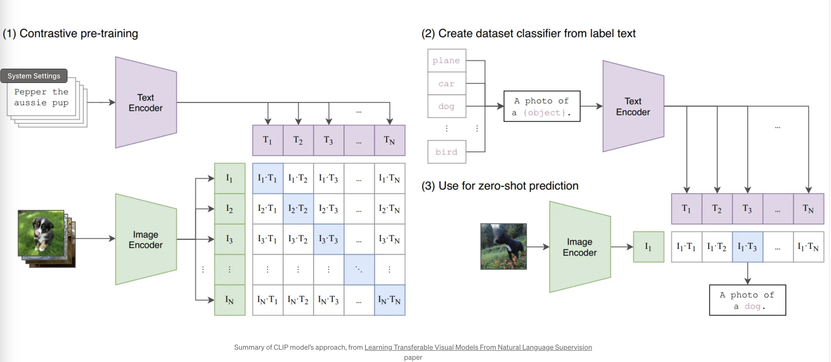

**Siamese Network**

A **Siamese network** is a neural network architecture that contains two or more identical subnetworks (sharing the same parameters) that process different inputs.

* **Functionality**: The network computes a similarity score between the outputs of the subnetworks. It is often used with contrastive loss, where it learns to distinguish between similar and dissimilar pairs.
* **Applications**: Common applications include face verification, image retrieval, and any task where determining similarity is crucial.

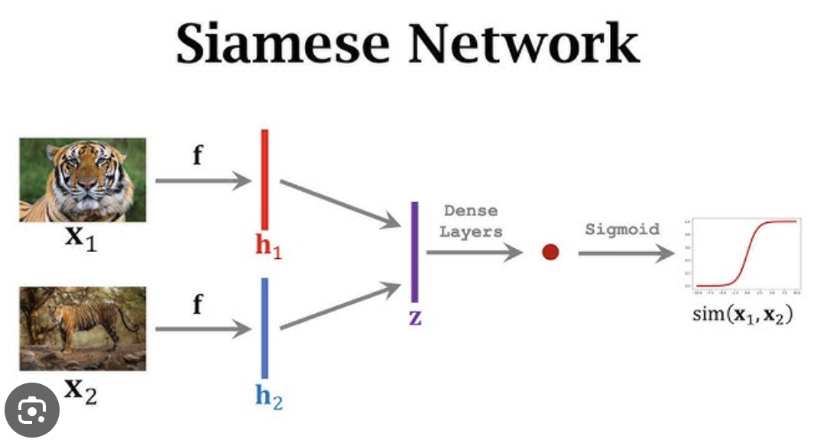

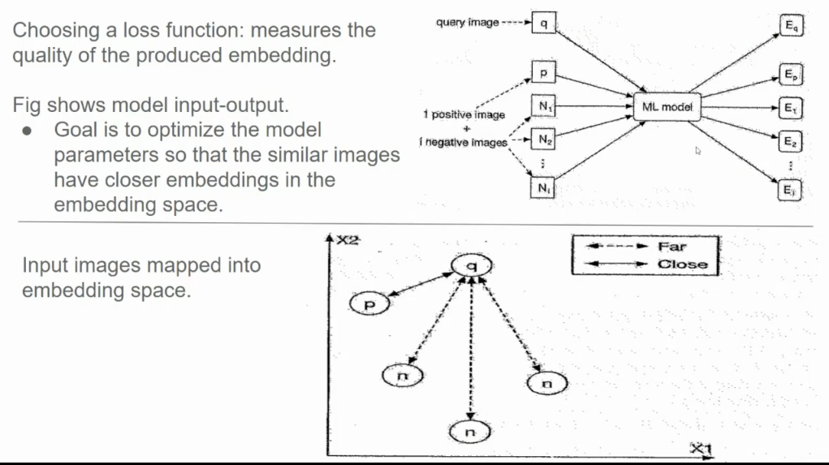

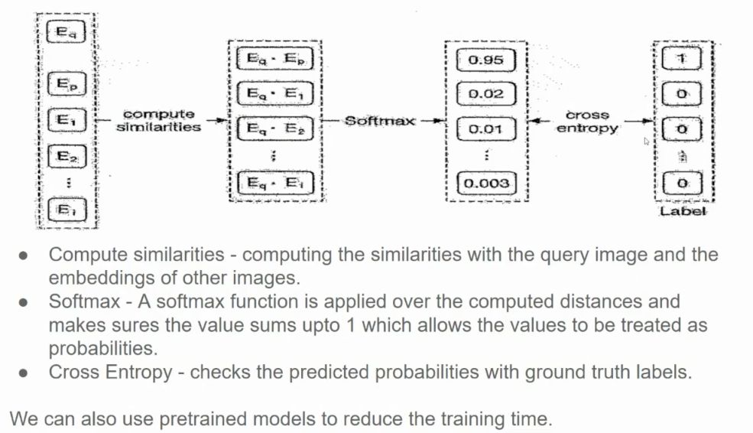

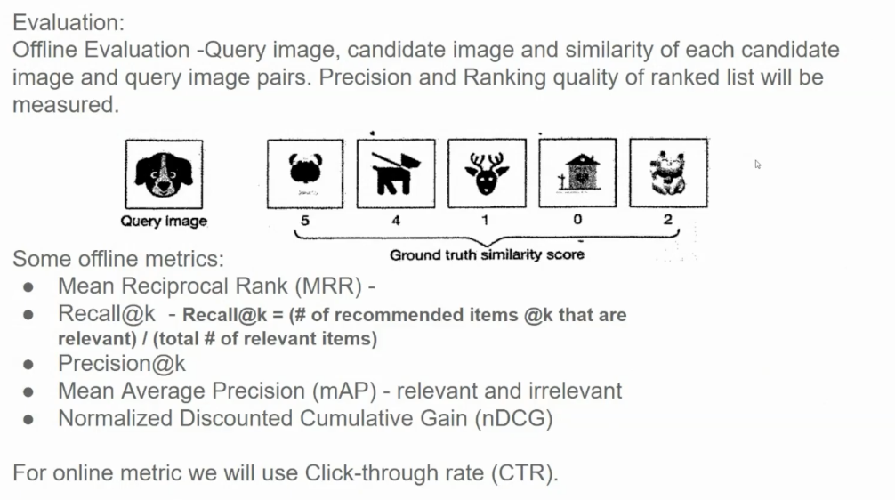

**1. Mean Reciprocal Rank (MRR)**

* **Definition**: MRR is a statistical measure used to evaluate the effectiveness of an information retrieval system. It is particularly useful in scenarios where a system returns a ranked list of results.
* **Calculation**: It is calculated as the average of the reciprocal ranks of the first relevant result for a set of queries.

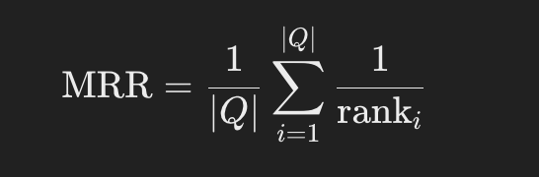

where ∣Q∣|Q|∣Q∣ is the total number of queries, and ranki\text{rank}_iranki​ is the rank of the first relevant result for query iii.

**2. Recall@k**

* **Definition**: Recall@k measures the ability of a model to retrieve relevant items in the top kkk results.
* **Calculation**: It is calculated as the ratio of the number of relevant items retrieved in the top kkk to the total number of relevant items available.

** 3. Precision@k**

* **Definition**: Precision@k assesses the accuracy of the top kkk retrieved items, indicating how many of them are relevant.
* **Calculation**: It is computed as the ratio of relevant items in the top kkk to the total items retrieved in that set.

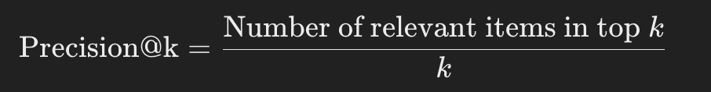

**4. Mean Average Precision (mAP)**

* **Definition**: mAP is an average of precision values at different levels of recall across multiple queries. It is commonly used in information retrieval and object detection tasks.
* **Calculation**: It is computed as the mean of average precision values for each query.

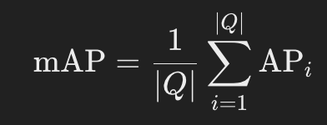

where APi\text{AP}_iAPi​ is the average precision for query iii, calculated as the average of precision scores at each point a relevant item is retrieved.

**5. Normalized Discounted Cumulative Gain (NDCG)**

* **Definition**: NDCG is a measure of ranking quality, emphasizing the importance of highly ranked relevant items. It is particularly useful when the relevance of items is graded rather than binary.
* **Calculation**: It combines the concept of cumulative gain (relevance scores) with a discounting factor based on the rank position.



NDCG is then calculated as:



where IDCG is the ideal DCG, the DCG obtained from the perfect ranking of items.

**6. Click-Through Rate (CTR)**

* **Definition**: CTR is a metric used to measure the effectiveness of online advertising campaigns, indicating the percentage of users who click on an ad after seeing it.
* **Calculation**: It is calculated as the ratio of the number of clicks to the number of impressions.

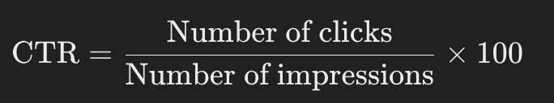

These metrics provide different insights into the performance of information retrieval systems, recommendation systems, and online advertising campaigns, allowing for a more comprehensive evaluation of effectiveness.

1. Serving

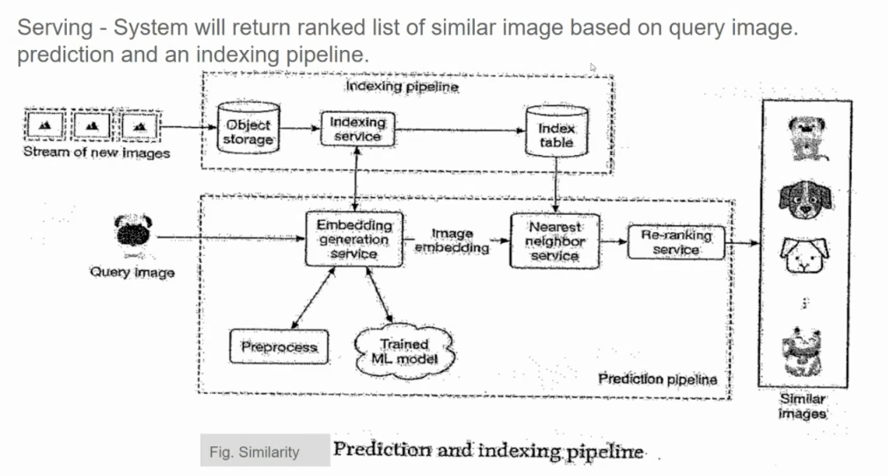

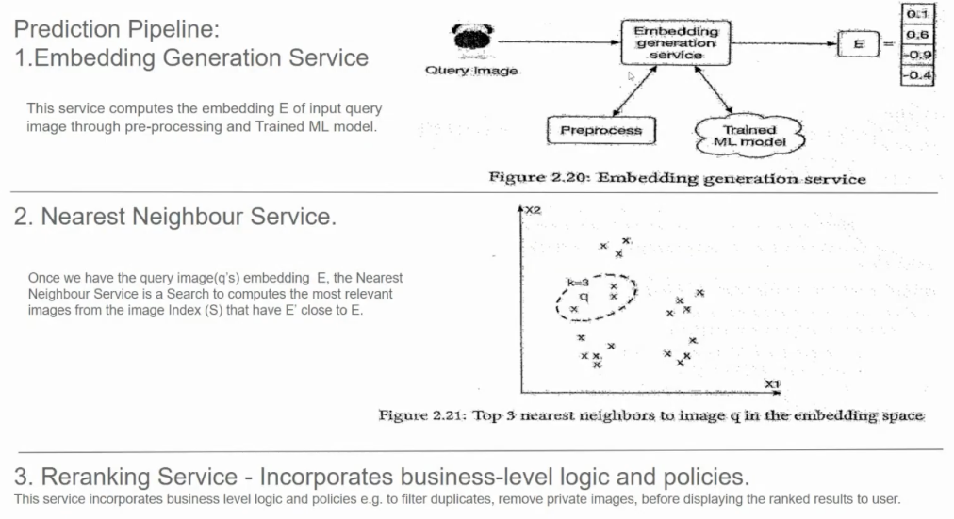

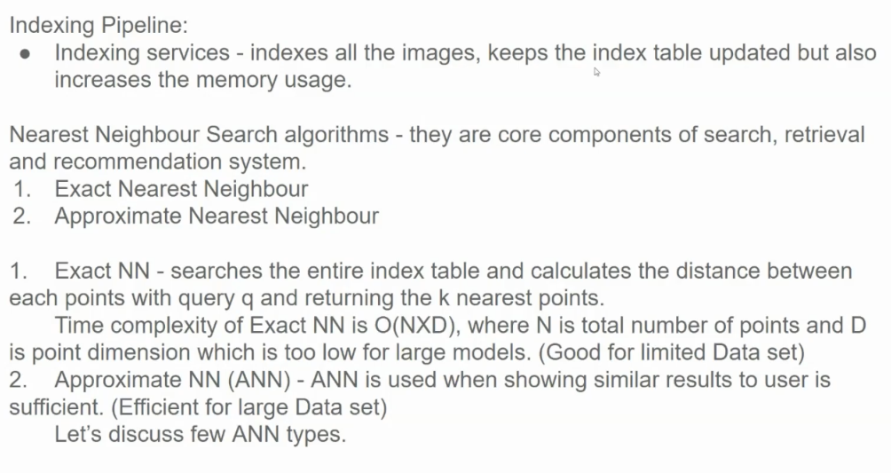

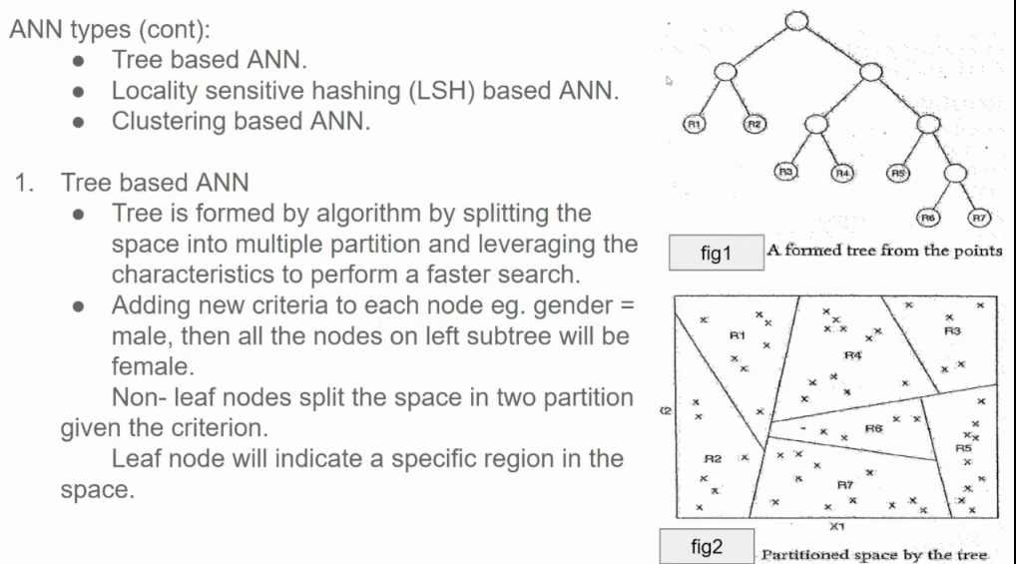

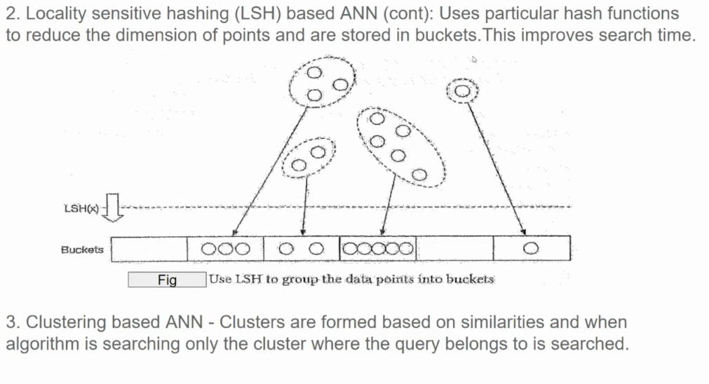

**How LSH Works:**

1. **Hash Functions:** LSH uses specially designed hash functions that map similar points to the same bucket with high probability. These functions are often based on random projections or p-stable distributions.
2. **Hashing and Bucketing:** Data points are hashed using multiple hash functions, and each hash function maps the point to a specific bucket.
3. **Querying:** When a query point arrives, it is hashed using the same hash functions.
4. **Candidate Retrieval:** The algorithm only needs to search the buckets that the query point hashes to. This significantly reduces the search space compared to a brute-force search.
5. **Similarity Calculation:** Within the candidate buckets, the query point is compared to the data points using a similarity metric (e.g., Euclidean distance, cosine similarity) to find the nearest neighbors.

